# Government High School Rajanukunte

Note: Add general details of high school

1)**Head Master**: Kanataraju B G

Education: M.Sc, M.Ed, KES

Date of Joining- 15-06-2007

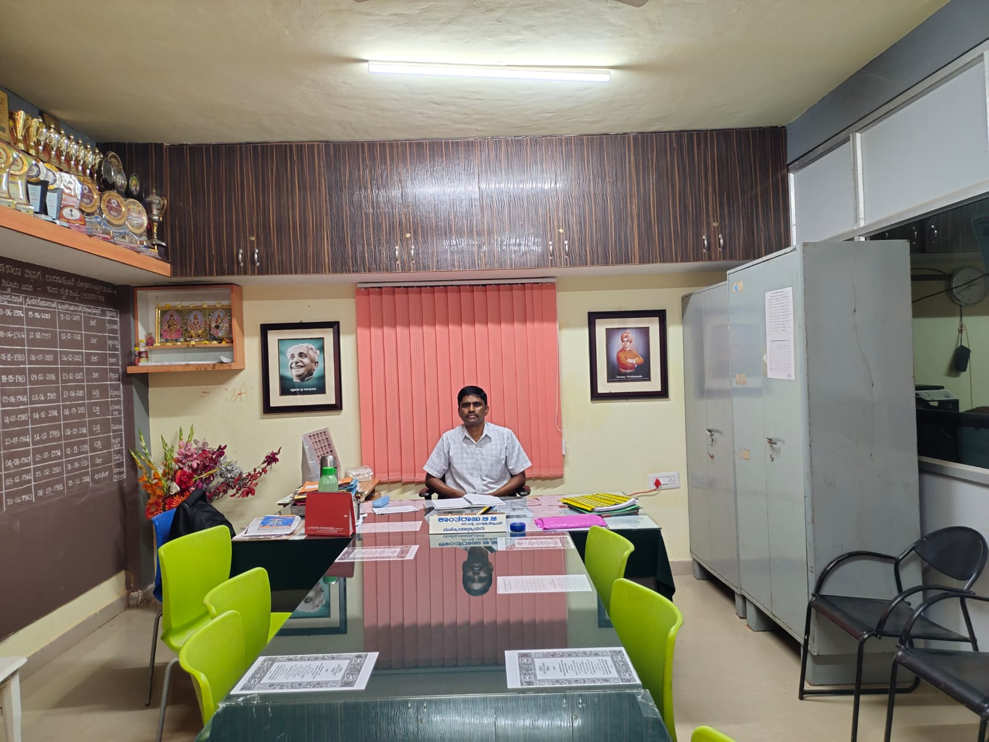Teaching Experience- 17 Years

2)Suguna SM- (PCM)

Education: M.Sc, B.Ed

Date of Joining- 12-07-1997

Teaching Experience- 27 Years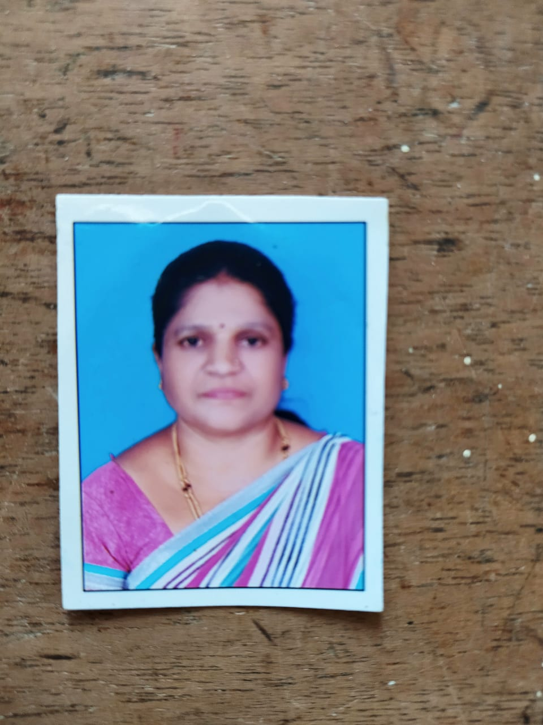

3)Uma Dindoor(Arts)

Head of Tourism, Event and Cultural Dept. GHS Rajanukunte

Education: MA, B.Ed

Date of Joining- 30-07-2007

Teaching Experience- 17 Years

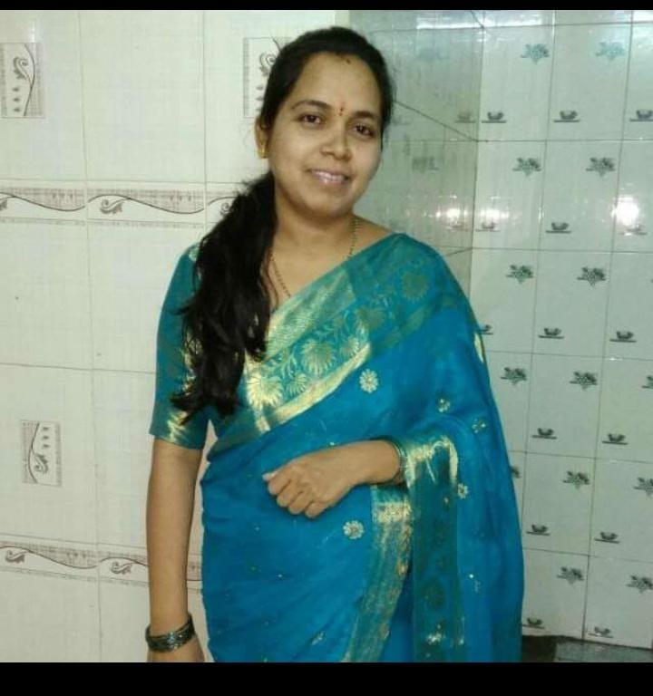

4)Shreedevi G(CBZ)

Head of Science and Technology Dept. GHS Rajanukunte

Education: B.Sc, B.Ed

Date of Joining- 09-07-2008

Teaching Experience- 16 Years

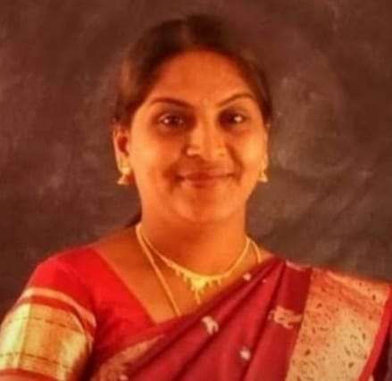

5)Manjula Bai S(Hindi)

Head of Library Dept. GHS Rajanukunte

Education: MA, B.Ed

Date of Joining- 03-06-1985

Teaching Experience-39 Years

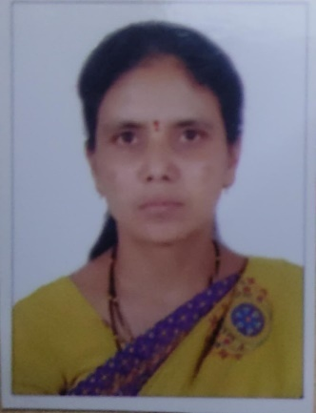

6)Siddangangamma (Kannada)

Head of Controller of Examination (COE) GHS Rajanukunte

Education: MA, B.Ed

Date of Joining- 14-02-1985

Teaching Experience- 39 Years

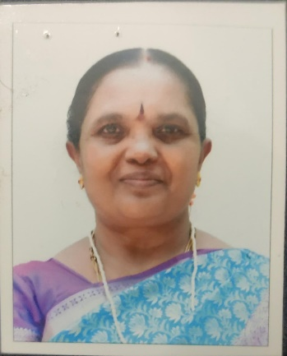

7)Vedavati Bhat(PT)

Head of Physical Education and National Festivals. GHS Rajanukunte

Education: M.P.Ed

Date of Joining- 25-07-1994

Teaching Experience- 30 Years

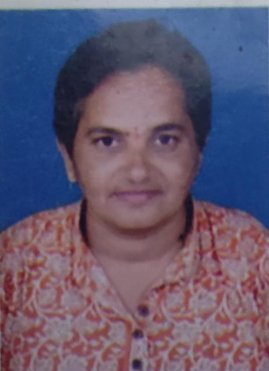

8)Katyayani. S

Education: PUC

Date of Joining- 21-10-2017

Teaching Experience- 7 Years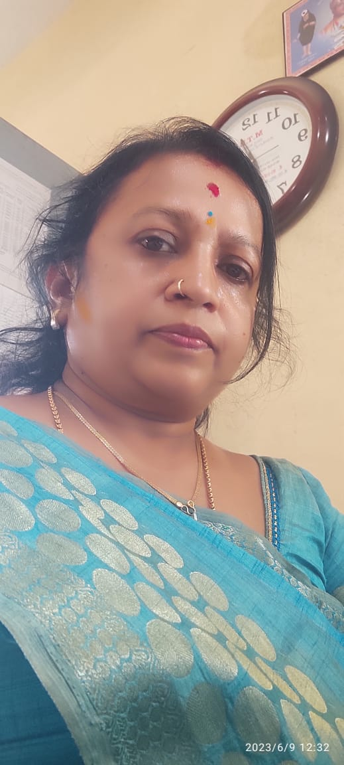

9)Mr. Balaiah D

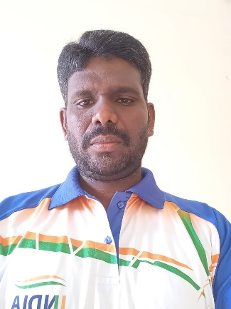

Swimming coach

National Swimmer

Experince – 24 years